Breadth First Search (BFS)
Aim
To implement the Breadth First Search (BFS) algorithm for traversing a graph.
Objectives
- To understand graph traversal techniques.
- To visit nodes level by level.
- To find the shortest path in an unweighted graph.
- To implement BFS using a queue.
Algorithm
- Start.
- Create a graph.
- Select the starting node.
- Mark the starting node as visited.
- Add it to the queue.
- Remove a node from the queue and visit it.
- Add all unvisited adjacent nodes to the queue.
- Repeat until the queue becomes empty.
- Stop.
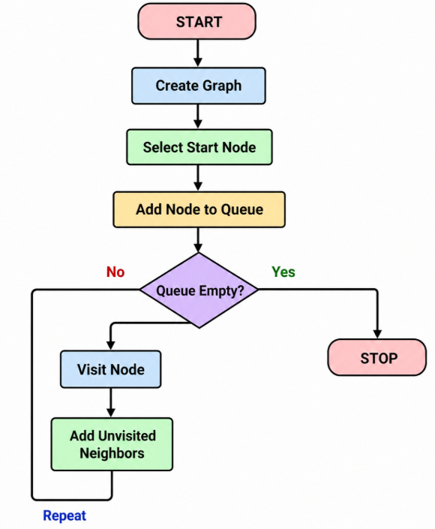
PROGRAM
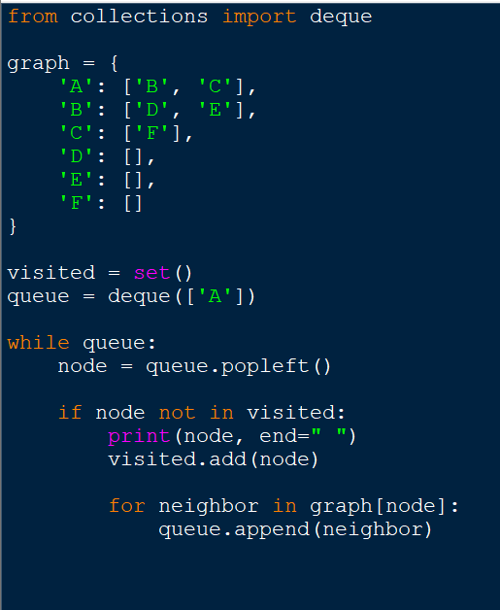

OUTPUT

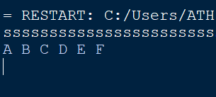

Result
The BFS algorithm was successfully implemented and traversed the graph level by level.

